
You are cordially invited to a Summer Evening Garden Party
wandering the Renowned Gardens of

Wyken Hall, Stanton IP31 2DW

By kind permission of Sir Kenneth and Lady Carlisle

Thursday 5th June 2025 6pm to 8.30 pm

A member of the Carlisle Family will give an introductory talk about the renowned
Gardens and you are then free to wander around at your leisure.

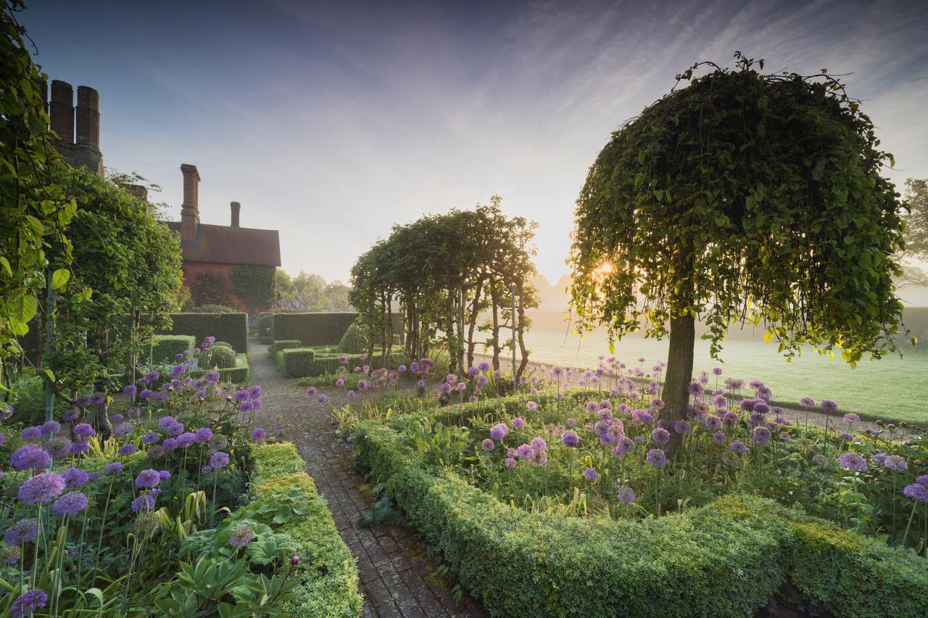

The Gardens: Formal gardens crammed with topiary, herbs, roses, box, fruit trees.
Meandering peacocks, guinea fowl and chickens snuggle up to the Elizabethan
manor house with head-high yew hedges serving as windbreaks, essential in East Anglia, a region renowned for its “lazy winds”.

£25 per head Licensed Bar Raffle

Price includes:

SAUSAGE & BURGER in a ROLL BARBEQUE by ROLFES OF WALSHAM LE WILLOWS

PTO for payment details
Payment in advance before the event and the last date for booking is Thursday 29th May

Payment by BACS please wherever possible.

Bank LLOYDS SORT CODE 30-91-43 Account 01200033 “Quote 5 June”.

Please reserve me places for the Garden Party on Thursday 5th June

From Name and Names of Guests

Address

Address

Address

E Mail

Telephone Number

I/We have paid £

Please list any food allergies you or your guests have below.

Payment by cheque is possible. Cheques should be made payable to:

Bury St Edmunds and Stowmarket Constituency Conservative Association

Please post to the following address:

Bury St Edmunds and Stowmarket Constituency Conservative Association
St Andrews Castle, 33 St, Andrews Castle, St Andrews Street South,
Bury St Edmunds IP33 3PH

office@bsecca.org.uk

Telephone 01284 774802

Printed and Published by R. Houlton-Hart of behalf of BSESCCA both of St Andrews Castle 33 St Andrews Street South, Bury St Edmunds IP33 3PH.

